Assessment 1: Weekly Progress

Keniel Dacosta

###### MSc Audio Technology

###### 7MU011 Audio Technology Project 2020/21

###### For the attention of:

# July - Week 1

For the Dissertation of my MSc in Audio Technology we were presented with a number of choices or routes to pursue the dissertation in. I had chosen the option of Music/Software development. The reason for my choice was really to explore and develop my skills in this area, and to become more proficient. I initially wanted to create a hybrid which would be a combination of the music/software development and musical interfaces/controllers (may also include a performance aspect). Due to my lifestyle/responsibilities and the changes covid 19 had brought to them, just focusing on the one element of software development would be more doable and not to overload myself with work knowing I have to manage work, family and academics.

With my route chosen i drawed on my experiences as a music producer who had been using software sampler, synthesizer plugins for the majority of this journey. I wanted to develop some kind of software in this domain. I have always been fascinated with the synthesizer plugin and innovation that spectrasonics have brought to the market and during the year of the release of the film Avatar. I found out that Omnisphere 2 was used in the scoring of the film. This plugin really was impressive for me.

The granular feature in Omnisphere 2 was an amazing addition, that as a producer i utilised to create sounds from samples that i could never before imagine of doing. This granular feature caused me to look further into granular synthesis within general.

I visited the spectrasonics website to find out more information.

<https://support.spectrasonics.net/manual/Omnisphere2/25/en/topic/layer-page-oscillator-page29>

The link provides a lot of information around the spectrasonics plugin but more so information about the granular feature and how it works.

# July - Week 2

My search led me to look into the history of Granular Synthesis and the key members in the field of its discovery.

<https://www.jstor.org/stable/3679937> - Introduction to Granular Synthesis By Curtis Roads

I came across this Journal Article by Curtis Roads from Computer Music Journal for which contains information about the history of granular synthesis

1.Dennis Gabor was hailed as the first person to apply the concept of quantum mechanics to human communication and hearing and from this theory and practice resulted in granular synthesis this was reflected in his work quanta

2.Then iannas xenassis was the first to then put this theory in practice after being inspired by gabors work he began cutting up tape to crete the phenomena of granular synthesis in music

3.Curtis Road 1979 first implemented it in the digital domain and brought granular synthesis to the digital world.

I found a number of sources of information for which I will be using to build my literature review.

# July - Week 3

I begin to compare differences in GUI, special features, accessibility, common controls etc. really to look at what the plugin is doing that I can maybe incorporate in my work. I found that a lot of these granular synthesis softwares follow a general approach to the GUI layout to which I have noticed there's usually a graphical representation on what's happening to the audio when being manipulated displayed in a window that is usually located at the centre of the GUI. I then looked at other softwares that offered granular synthesis such as Malstrom (Reason), Izotope, NI, I then read and article that was talking about granular synthesizer/samplers which pointed out the rarity in hardware granular samplers/synthesizers

<https://www.synthanatomy.com/2018/08/best-hardware-granular-samplers-synthesizers.html>

This made me think about the hybrid of a software/hardware granular synthesis development, however this would still prove to be difficult a task to complete in the time frame.

# July - Week 4

Upon beginning my search for what is out there around granular synthesis in regards to pure data quickly led me to finding out that the version of pure data I was using was no longer supported. Which was PD extended, the alternative is PD vanilla. When looking back at some of my previous pure data projects with the hope to use previous code and remind myself of the working of pure data. I came to realise that pure data extension was no longer supported. Having to now use pure vanilla will mean I am not able to use a lot of the objects that I was once familiar with thus causing me to relearn new ways to possibly do the same things. However I have been reading a lot on the pure data forums to which users have stated alternatives for objects such as the knob which was a visual object used instead of the meters and presented better as being analogous to the real thing. Whilst this presents a small set back in my workflow in puredata I am still pretty confident I can complete my project in the way I want.

# August - 28th

I have begun to design my pure data patch from a visual perspective using the canvas and graph on parent toll with any usable object. I have really mimicked the visual layout of omnisphere but, at this stage in the development this might change. I have also tried to follow what I have noticed as a common approach to the layout of the design. The illustration below is what I have done so far. This is to give me an idea of the interface, the inner working of the patch (code) has not been implicated yet but the design is informed by my research, and found this to be the most common approach used in the industry. A huge visual representation of what is happening with the wave is usually located in the centre of the console, this is then followed by controls surrounding.

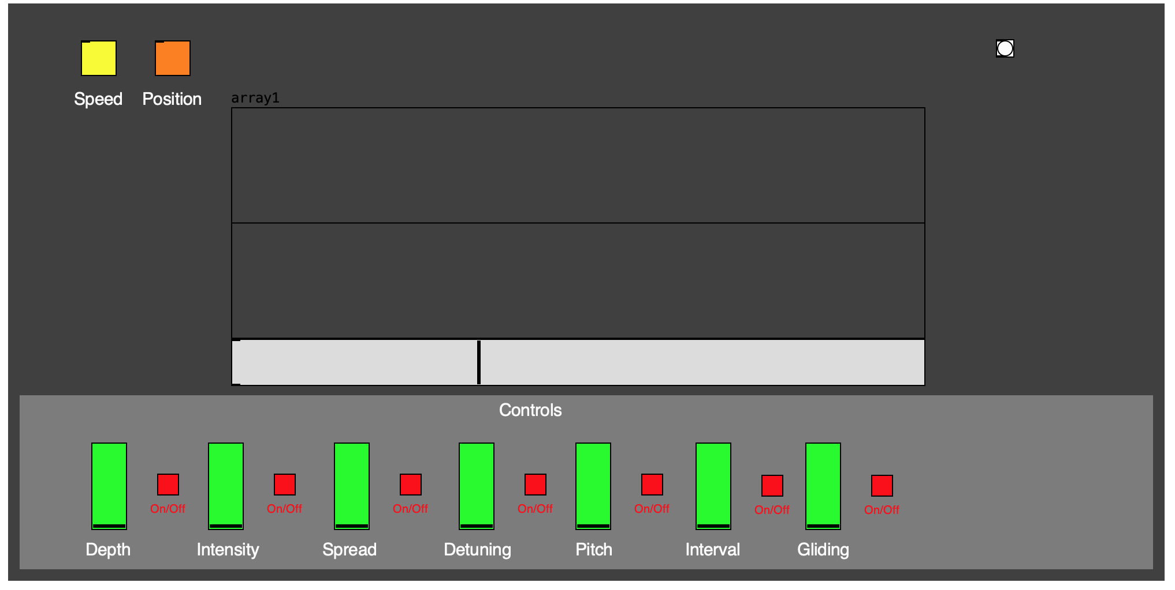

# August - 29th

Thinking about the overall project, I am still unsure how my research will connect with the development of my software, the reason for me doing it, or the question as to say. At the moment I feel like I am just mimicking a granular synthesiser without being able to bring something of my own to the table. This is partially because of my unfamiliarity with pure-data vanilla and my overall ability. and also due to the stage we have reached in granular synthesis with cutting edge manipulation controls which I feel are too advanced for me to begin to take such an approach.

# September - 1st

Today I did research around the various patches that have been created to mimic granular synthesis. I started with youtube which brought a number of results showing patches being created that perform granular synthesis with audio and manipulation.

My second source of research took me to the pure data forums

<https://forum.pdpatchrepo.info/topic/13271/granular-sampler-granular21> - granular sampler

<http://www.pd-tutorial.com/english/ch03s07.html> - granular synthesis

<http://maxwellsmith.net/patches/> - polytonal grains (This patch i found very interesting, the layout and the visual feedback it gave the user)

[PureData tutorials - rich synthesis (19) - Granular Synthesis](https://www.youtube.com/watch?v=NxfgfFSPaEw)

[Granular Audio Manipulation in Pure Data](https://www.youtube.com/watch?v=tpL7l4oX42Q)

Popular features

Times stretching/Pitch shift wich equal granular speed

Grain size wich equals choppiness or smoothness of playback this is in milliseconds

Live sound of audio file in pure data

Amount of grains and being able to select how many grains

Grain density is how often 1 grain is played the more dense is the faster 1 grain is looped the less dense than the slowed 1 grain is looped

Backward and forward playback

# September 2nd

Top 10 granular synthesizer plugins

Because of its eclectic nature, granular synthesis is best used as a textural technique, often for **drones, pads, and interesting noise layers**

**Top 5 Best Granular Synth VST**

* Native Instruments Form.
* Spectrasonics Omnisphere.
* Glitchmachines Palindrome.
* Glitchmachines Polygon.
* MeldaProduction MGranularMB.

# September 3rd

With the help of my tutor there has been a lot of clarity brought to the project in terms of the research question. Having more understanding of what I am doing has meant that I can connect the research to my decision for influence of design , workings and what it is I am setting out to do.

With this charity it is with a view to explore the process of developing a granular synthesis within the pure data environment. i will dig into this further with the literature review.

# September 4th

Today I worked on my Pure Data patch by implementing code into the patch. I started out with constructing the code for generating 1 grain. I followed a youtube video [41. Granular Synthesis with Pure Data](https://www.youtube.com/watch?v=QX_saH55cks&t=8s). The function allows for the user to open and select a sample form the hard drive, then select an specific starting point in the audio wave and set the duration of a grain in milliseconds and the speed at which the grain of audio is looped. So far the code works to a degree but not working how intended, specifically the sliders that control the position length and speed of the grain.

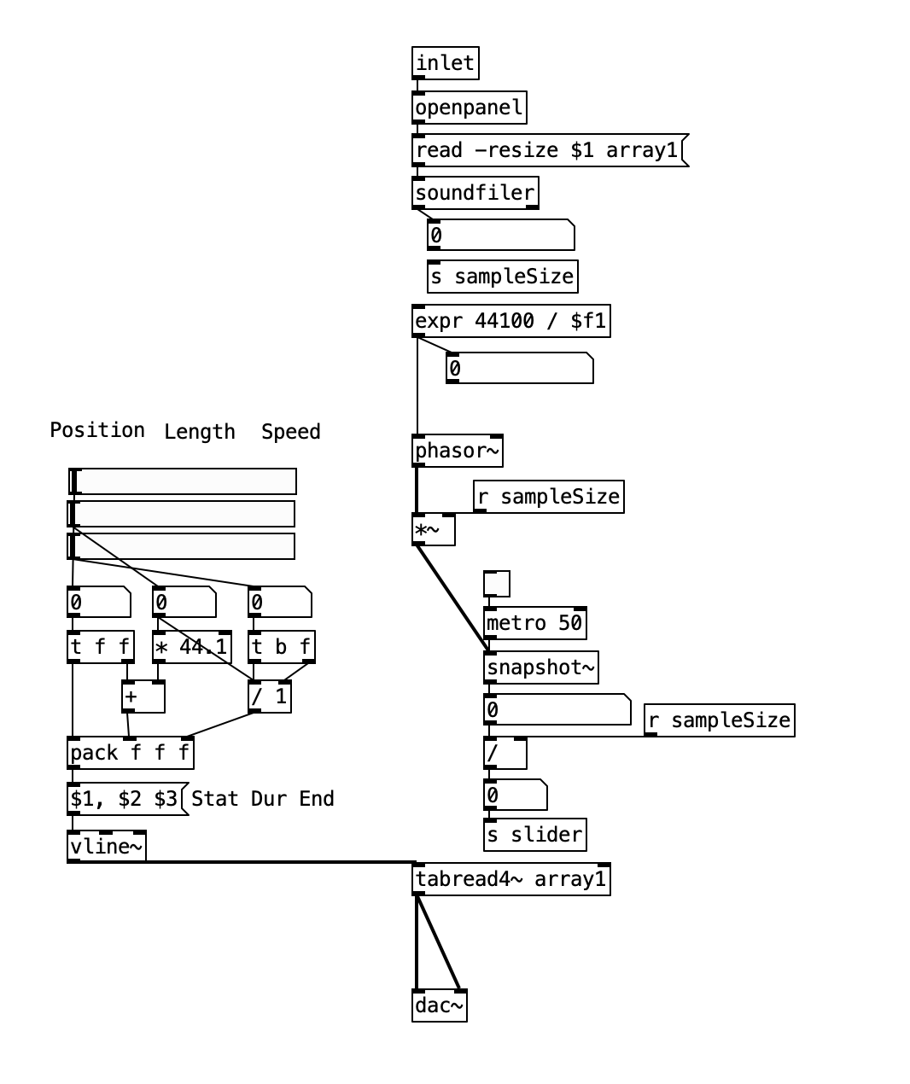

# 

# 

# 

# 

# 

# September 5th

Today I have been trying to get the visual aspect of the patch working in terms of the visual representation of where in the audio file the user is located to edit a grain. so the illustration below is the patch with an audio file loaded into it, this is a kick drum. The grey slider below it shows the positioning within the audio file and the speed at which it is playing. so far this works in terms of functioning. there's only the need to maybe make it more visually easter to interpret.

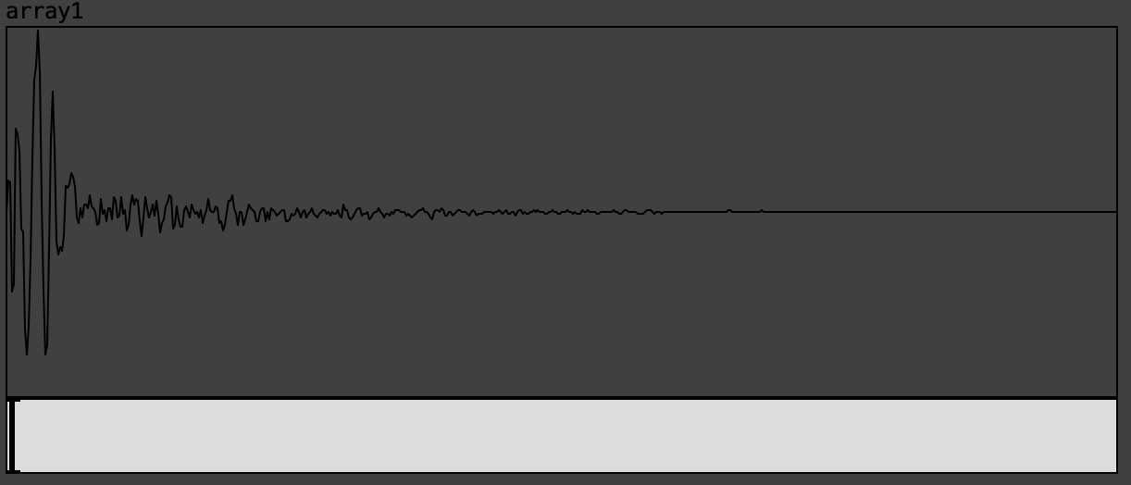

# September 6th

i came across this youtube video [Granular synthesis on audio file with Pure data](https://www.youtube.com/watch?v=Y6YIsLYcaI0) which was demonstrating a patch in granular synthesis. This patch looked very similar to the code I am using. however the functionality of the patch looks a lot more fluent and efficient. my aim will be to download or recreate the patch to compare to my existing one in order to get this section of code functioning correctly. By merging parts of this patch with my existing one I am hoping to finalise the guts of the granular.

although this patch is to generate 1 single grain taken from a audio file the aim is to generate a number of grains, also what can be done with one grain using these parameters creates sounds that arent really musically applicable so its with an sumption that generating more grains will generate more harmonic content providing richer sounds

Puredata Patch Code - (https://github.com/maximoskp/pdFileGranulator)

# September 7th

starting to construct my puredata patch i started to watch this youtube video [PURE DATA: 22 Advanced Audio with [tabread4~]](https://www.youtube.com/watch?v=boX0v54SqtU&t=94s) demonstrating a patch where the user can select an audio file on the hard rive and using the array tables get a vusal representation of the audio file and a slider to show positioning. the acth has a control parameter for start, pause/stop, restart and playback speed, stereo output and volume slider. this became my starting point as the need to be able to select and audio file on the hard drive or external usb etc and load it into the granular sampler, the array will be needed for the user to see the audio file and where in that file playback is positioned. there is no need for a left and right array as common approach is usually 1 visual spectrum usually in the centre of the console therefore left and right is combined or just a mono signal. from this patch i plan the expand it by merging the features for then generating 1 grain.

# September 8th

the user needs to be able to bring audio into the software and manipulate it using granular synthesis, the audio file needs to be represented visually and the location within the audio file. the user needs to be able to generate 1 or more grains from the audio file of specify variable lengths, also effects like reverb and delay be able to loop grains and randomize, being as those this is intended for a vst plugin to be used within a DAW the ability to trigger using a keyboard will be implemented.

# September 9th

# September 10th

# September 11th

**Reflective Diary**

This will document the journey of the dissertation from start to finish, detailing thoughts and feelings, research and software development, the routes taken that have led to information that has informed my project. Involving media such as picture/images or pd code will be used.

**Puredata Patch (Granular)**

This will be developed in Puredata using code that has been adapted from other patches. The overall design of the patch will be and the functionality of it will be informed by my literature review and researching current designs on the market. The functionality of the patch will be based around the general functions found when performing granular synthesis.

**Report**

This will consist of

Introduction - Introducing the project its aims and what I hope to achieve by undertaking this.

Literature review - research around granular synthesis and its key players, the development of granular synthesis over the years. From this extract the research question wich will be to implement a working granular synthesis patch in Puredata and looking into the process that is required in order to do so. This will be the task and overall aim.

Methodology - The objectives of how I will go about creating the project. Detail the specific software's that will be used the

Results - how the overall patch/ project turned out the issues involved. If it met my intentions of what I was trying to create. ( videos to help illustrate the patch working and results)

Conclusion - What could have been changed to work better. Any solutions that could be suggested to improve the functionality or the interface. Real world applications.

# September 12th

# September 13th

# September 14th

# September 15th

# September 16th